**Exercise 2**

1. Java program to calculate average marks of students

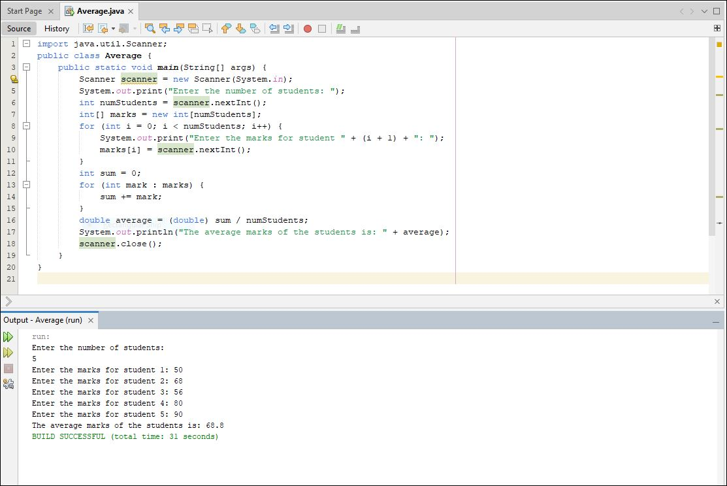

1. Java program to compute interest of payment for helb loan

